**Ideation Phase**

**Brainstorm & Idea Prioritization Template**

|  |  |
| --- | --- |
| Date | 15 June 2025 |

ve solutions.

Use this

Reference: <https://www.mural.co/templates/brainstorm-and-idea-prioritization>

**Step-1: Team Gathering, Collaboration and Select the Problem Statement**

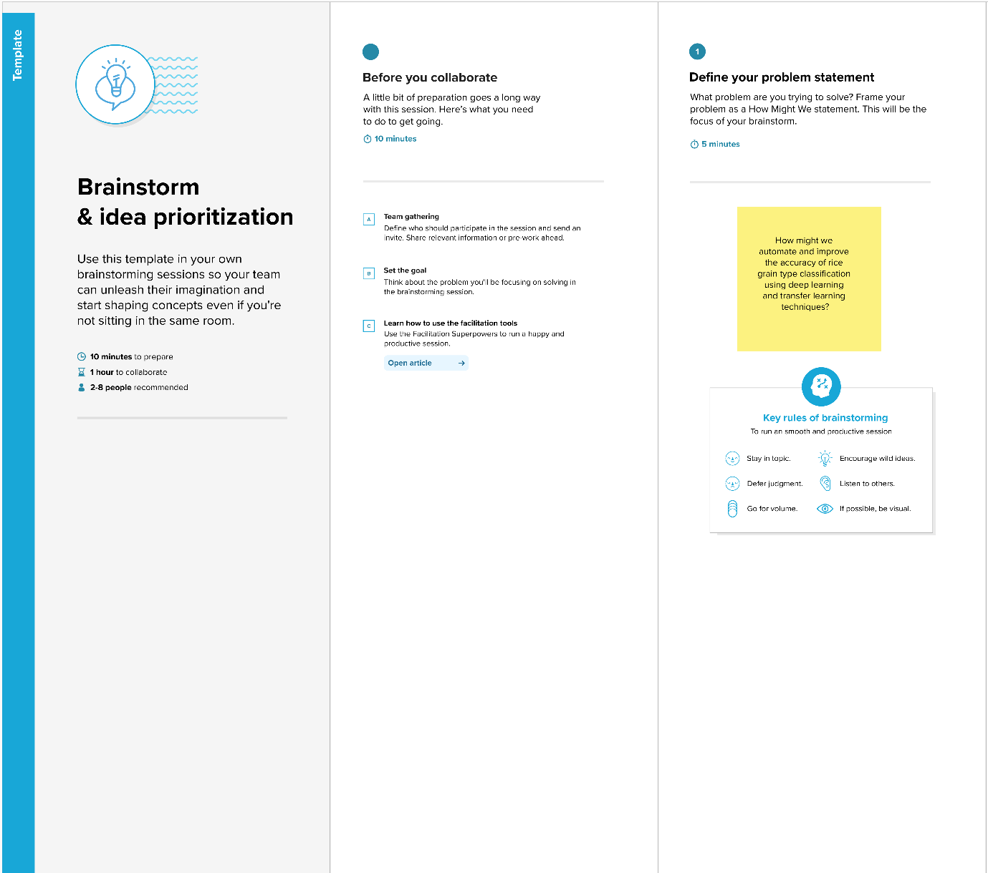

**Step-2: Brainstorm, Idea Listing and Grouping**

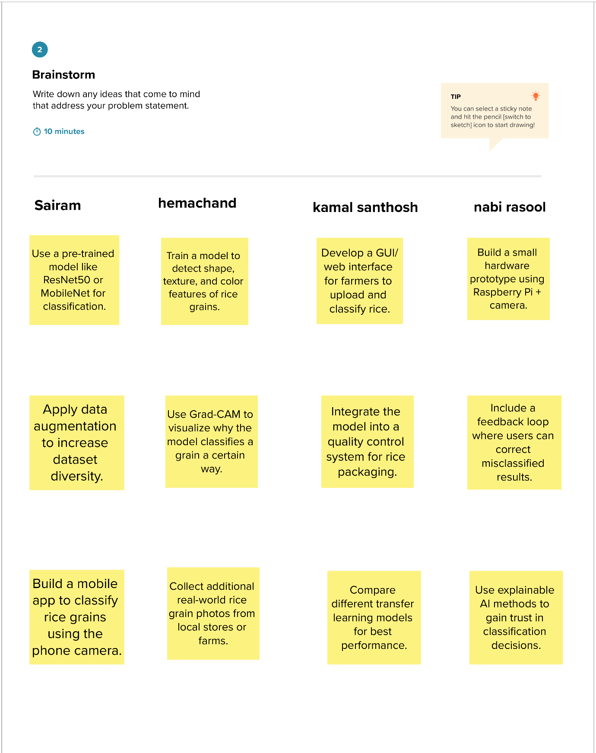

**Step-3: Idea Prioritization**

